Japanese Cities' Names
Easy
Basic Select
Query the names of all the Japanese cities in the CITY table. The COUNTRYCODE for Japan is JPN.
The CITY table is described as follows:
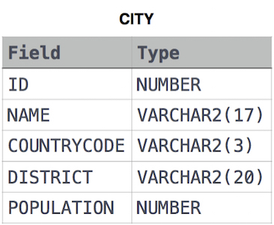
Query:-
SELECT NAME
FROM CITY
WHERE COUNTRYCODE='JPN';

Congratulations!
You have passed the sample test cases. Click the submit button to run your code against all the test cases.
Sample Test case 0

Your Output (stdout)
- Neyagawa
- Ageo
- Sayama
- Omuta
- Tokuyama

